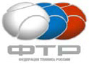
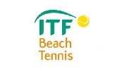
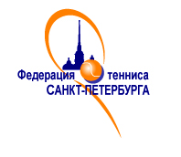

Международный турнир по пляжному теннису ITF
«CHRISTMAS CUP»
20-22 ДЕКАБРЯ 2013

WOMENS

1. Kirgizova Ekaterina 58 (RUS) / Sizonenko Natalya (RUS) 51
2. Nikoyan Liudmila (RUS) 63 / Churakova Daria (RUS) 63
3. Stepanova Natalia (RUS) 73 / Naumova Stanislava (RUS) 108
4. Moiseeva Anastasia (RUS) 117 / Livanova Regina (RUS) 174
5. Makedonskaya Natalia (RUS) 384 / Romashkina Tatiana (RUS) 384
6. Sergeeva Irina (RUS) 596 / Iudina Natalia (RUS) 0
7. Ilyukhina Natalia (RUS) 269 / Zheleznova Anna (RUS) 0
8. Chubarova Julia (RUS) 0 / Glimakova Irina (RUS) 596
9. Zudilina Ekaterina (RUS) 0 / Rotova Svetlana (RUS) 596
10 . Ponomareva Daria (RUS) 596 / Veselova Anastasia (RUS) 0
11.Kholodnaya Anna (RUS) 0 / Panfilkina Zhanna (RUS) 596
12. Iakovleva Anna (RUS) 0 / Evtushenko Kristina (RUS) 596
13. Pashko Nadezhda (RUS) 0 / Samoshkina Ekaterina (RUS) 0
14. Borodulina Tatiana (RUS) 0 / Lopatina Natalia (RUS) 0
15. Vahtramae Anneliis (EST) 0 / Loit Anneli (EST) 0
16. Noskova Nataliia (RUS) 0 / Kudinova Olesia (RUS) 0
17. Borisenkova Daria (RUS) 0 / Soloveva Elena (RUS) 0
18. Ivanova Marina (RUS) 0 / Chekirda Elizaveta 0
19. Bobyleva Natalya (RUS) 0 / Davydova Ekaterina (RUS) 0
20. Shmeleva Ekaterina (RUS) 0 / Shimanskaya Margarita (RUS) 0
21. Rakova Svetlana (RUS) 0 /

