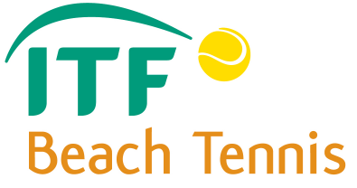
OFFICIAL ENTRY FORM
I.T.F. BEACH TENNIS
ITF Beach Tennis
LENINSKI DISTRICT CUP G-3
02-04 August 2013, Samara, Russia
ENTRY DEADLINE: 20 July 14:00 2013
* PLEASE WRITE IN BLOK CAPITALS
P L A Y E R N° 1
FIRST NAME: | SURNAME:
DATE OF BIRTH (dd/mm/yy):
SEX: | FEMALE
E-MAIL:
TEL. NUMBER:
NATIONALITY: RUS | ITF RANKING:
P L A Y E R N° 2
FIRST NAME: | SURNAME:
DATE OF BIRTH (dd/mm/yy):
SEX:
E-MAIL:
TEL. NUMBER:
NATIONALITY: | ITF RANKING:
PLEASE SEND EMAIL THIS ENTRY FORM TO THE ORGANISERS o.i.eiderman@gmail.com
SEE FACT SHEET FOR DETAILS.

